# **Задание 16.1**

public class Main {  
 public static void main(String[] args)  
 {  
 for (int i=0;i < 4; i++)  
 {  
 for (int j=0; j < 5; j++)  
 {  
 System.*out*.println(i + j);  
 }  
 }  
 }  
}

Ответ:

0

1

2

3

4

1

2

3

4

5

2

3

4

5

6

3

4

5

6

7

# **Задание 16.2**

public class Main {  
 public static void main(String[] args)  
 {  
 for (int i=0;i < 4; i++)  
 {  
 for (int j=0; j < i; j++)  
 {  
 System.*out*.println(i*j);  
 }  
 }  
 }  
}

Ответ:

0

0

2

0

3

6

# **Задание 16.3**

public class Main {  
 public static void main(String[] args)  
 {  
 for (int i=0;i < 4; i++)  
 {  
 int s = 0;  
 for (int j=0; j < i; j++)  
 {  
 s = s + i + j;  
 System.*out*.println(s);  
 }  
 }  
 }  
}

Ответ:

1

2

5

3

7

12

# **Задание 16.5**

public class Main {  
 public static void main(String[] args)  
 {  
 for (int i = 1; i< 6; i++)  
 {  
 System.*out*.print(i+": ");  
 for (int j = 10; j < 100; j++) {  
 if (j%(i+1)==0)  
 System.*out*.print(j + " ");  
 }  
 System.*out*.println();  
 }  
 }  
}

Ответ:

1: 10 12 14 16 18 20 22 24 26 28 30 32 34 36 38 40 42 44 46 48 50 52 54 56 58 60 62 64 66 68 70 72 74 76 78 80 82 84 86 88 90 92 94 96 98

2: 12 15 18 21 24 27 30 33 36 39 42 45 48 51 54 57 60 63 66 69 72 75 78 81 84 87 90 93 96 99

3: 12 16 20 24 28 32 36 40 44 48 52 56 60 64 68 72 76 80 84 88 92 96

4: 10 15 20 25 30 35 40 45 50 55 60 65 70 75 80 85 90 95

5: 12 18 24 30 36 42 48 54 60 66 72 78 84 90 96

# **Задание 16.6**

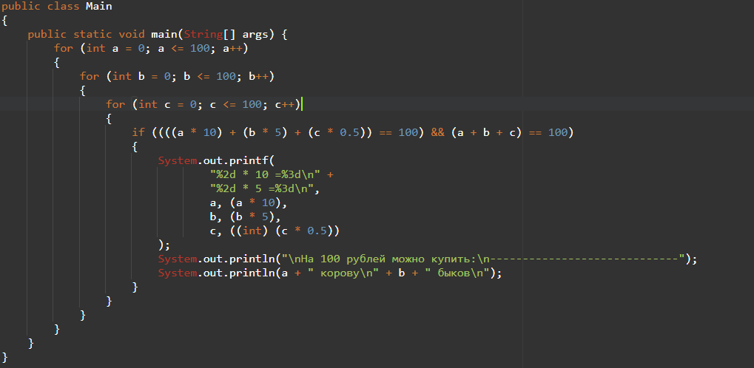

1 * 10 = 10

9 * 5 = 45

На 100 рублей можно купить:

-----------------------------

1 корову

9 быков

# **Задание 16.8**

public class Main {  
 public static void main(String[] args)  
 {  
 int sum = 0;  
 int n = 75;  
 for (int i = 1; i<=n; i++)  
 {  
 System.*out*.print(i+": ");  
 for (int j = 1; j <= i; j++){  
 if (i % j == 0) {  
 System.*out*.print(j + " ");  
 sum += j;  
 }  
 }  
 System.*out*.print("Sum = "+sum);sum=0;  
 System.*out*.println();  
 }  
 }  
}

Ответ:

1: 1 Sum = 1

2: 1 2 Sum = 3

3: 1 3 Sum = 4

4: 1 2 4 Sum = 7

5: 1 5 Sum = 6

6: 1 2 3 6 Sum = 12

7: 1 7 Sum = 8

8: 1 2 4 8 Sum = 15

9: 1 3 9 Sum = 13

10: 1 2 5 10 Sum = 18

11: 1 11 Sum = 12

12: 1 2 3 4 6 12 Sum = 28

13: 1 13 Sum = 14

14: 1 2 7 14 Sum = 24

15: 1 3 5 15 Sum = 24

16: 1 2 4 8 16 Sum = 31

17: 1 17 Sum = 18

18: 1 2 3 6 9 18 Sum = 39

19: 1 19 Sum = 20

20: 1 2 4 5 10 20 Sum = 42

21: 1 3 7 21 Sum = 32

22: 1 2 11 22 Sum = 36

23: 1 23 Sum = 24

24: 1 2 3 4 6 8 12 24 Sum = 60

25: 1 5 25 Sum = 31

26: 1 2 13 26 Sum = 42

27: 1 3 9 27 Sum = 40

28: 1 2 4 7 14 28 Sum = 56

29: 1 29 Sum = 30

30: 1 2 3 5 6 10 15 30 Sum = 72

31: 1 31 Sum = 32

32: 1 2 4 8 16 32 Sum = 63

33: 1 3 11 33 Sum = 48

34: 1 2 17 34 Sum = 54

35: 1 5 7 35 Sum = 48

36: 1 2 3 4 6 9 12 18 36 Sum = 91

37: 1 37 Sum = 38

38: 1 2 19 38 Sum = 60

39: 1 3 13 39 Sum = 56

40: 1 2 4 5 8 10 20 40 Sum = 90

41: 1 41 Sum = 42

42: 1 2 3 6 7 14 21 42 Sum = 96

43: 1 43 Sum = 44

44: 1 2 4 11 22 44 Sum = 84

45: 1 3 5 9 15 45 Sum = 78

46: 1 2 23 46 Sum = 72

47: 1 47 Sum = 48

48: 1 2 3 4 6 8 12 16 24 48 Sum = 124

49: 1 7 49 Sum = 57

50: 1 2 5 10 25 50 Sum = 93

51: 1 3 17 51 Sum = 72

52: 1 2 4 13 26 52 Sum = 98

53: 1 53 Sum = 54

54: 1 2 3 6 9 18 27 54 Sum = 120

55: 1 5 11 55 Sum = 72

56: 1 2 4 7 8 14 28 56 Sum = 120

57: 1 3 19 57 Sum = 80

58: 1 2 29 58 Sum = 90

59: 1 59 Sum = 60

60: 1 2 3 4 5 6 10 12 15 20 30 60 Sum = 168

61: 1 61 Sum = 62

62: 1 2 31 62 Sum = 96

63: 1 3 7 9 21 63 Sum = 104

64: 1 2 4 8 16 32 64 Sum = 127

65: 1 5 13 65 Sum = 84

66: 1 2 3 6 11 22 33 66 Sum = 144

67: 1 67 Sum = 68

68: 1 2 4 17 34 68 Sum = 126

69: 1 3 23 69 Sum = 96

70: 1 2 5 7 10 14 35 70 Sum = 144

71: 1 71 Sum = 72

72: 1 2 3 4 6 8 9 12 18 24 36 72 Sum = 195

73: 1 73 Sum = 74

74: 1 2 37 74 Sum = 114

75: 1 3 5 15 25 75 Sum = 124